

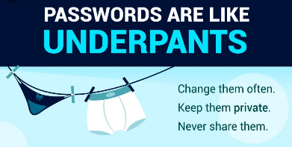

How to choose a password:
- At least 8 characters (mixture of characters).
- Must not contain your name.
- No complete words.
- No relevant names i.e. pets or known nicknames.
- No numbers that reflect birthdays or house numbers.


- CREATE A PASSWORD THAT’S EASY FOR YOU TO REMEMBER BUT HARD FOR OTHERS TO GUESS

- NEVER SHARE YOUR PASSWORD WITH ANYONE, NOT EVEN YOUR BEST FRIEND….. BUT …..IT IS OK TO SHARE IT WITH YOUR PARENTS.

