My Lighthouse Design
Who is your user? | What is the purpose of the lighthouse?
Light characteristic (circuit)
Day mark (outside view)

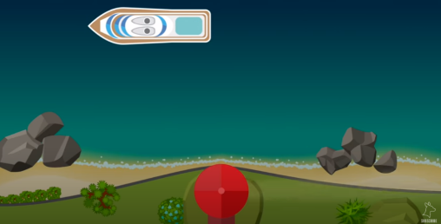
Success criteria: To be successful, my lighthouse must:

