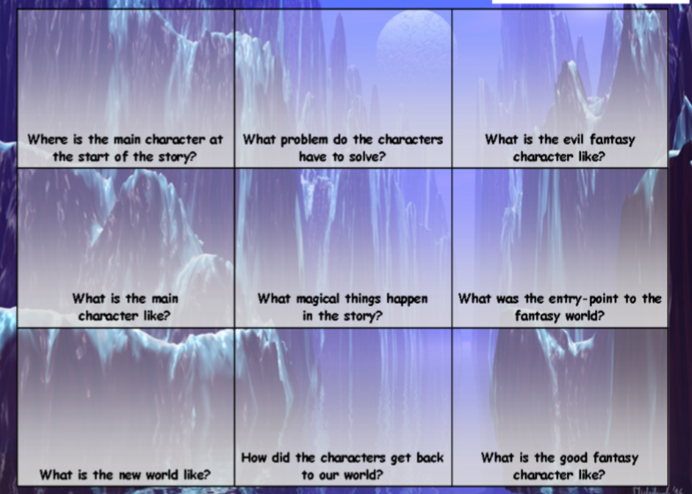
Fantasy Stories Things to think about.
Start jotting down your first ideas either in notes or picture form.

