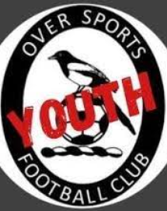
U8 Girls Only Football

Is your daughter currently in Year 1 or 2 at school?

Has she been inspired by the Lionesses?

Is she keen on playing football and looking to join a team?

Is she looking for a new sporting activity?

Over Sports Youth FC are an FA Charter Standard club looking for girls to join the squad for next season’s U8 girl’s only team playing in the Alan Boswell Group Cambridgeshire Girls & Women’s Football league.

Training currently takes place on a Sunday morning for one hour
10.00 – 11.00 at Over Community Centre.

Matches will take place on Saturday mornings

For further details E-mail: vikki.osyfc@gmail.com

Or contact…

Laurie Bell (Manager) 07443531535



