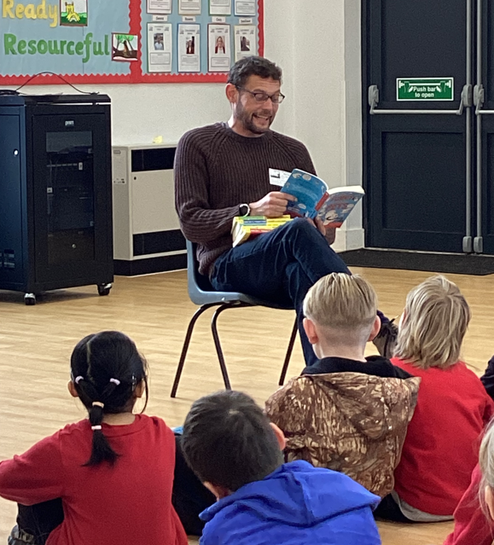

Author Visit 2024
As part of our World Book Day celebrations we invited author and comedian, James Campbell, into school to share his writing skills.
We had a blast listening to his funny storytelling. He inspired us to write our own stories.
Remember …. something with a small starting point can turn into something much bigger and juicier!


