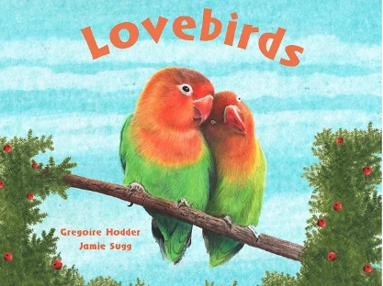
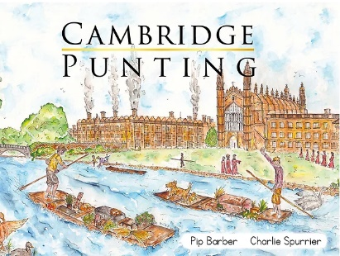
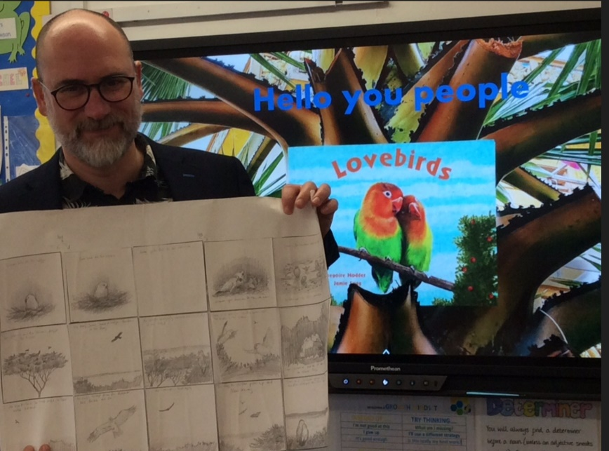
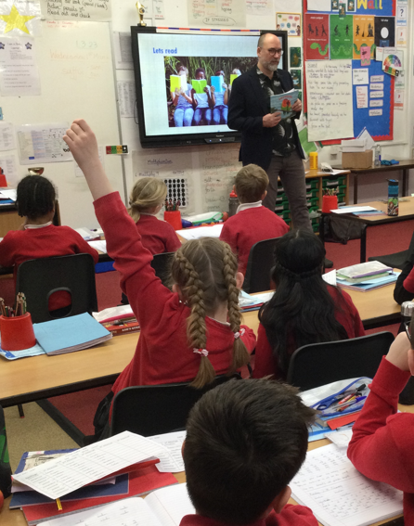
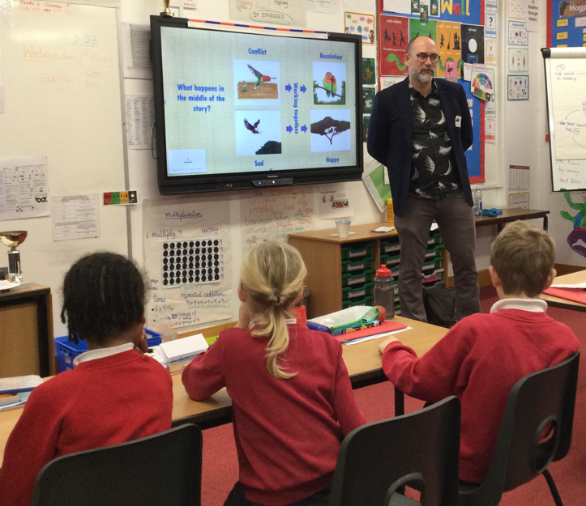

Author Visit 2023
At Swavesey, we think author visits are a wonderful way to get children excited about reading and writing.
Last year we welcomed authors Gregoire Hodder, who shared his love of reading and writing with KS2, and Pip Barber who took the younger children on an adventure around Cambridge.

