L.O. I can use different strengthening technique and evaluate the result
Use the techniques below to create a small strengthened base (bridge) then place the base in between two tables and test its strength using weights.
 | How many layers ? | How much does it hold?
Laminating
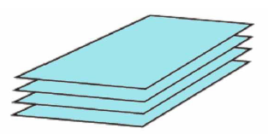
Corrugating
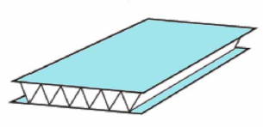
Ribbing
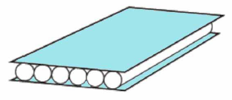
Tip: When corrugating or ribbing more than one layer, place the next layer perpendicularly from the one below.

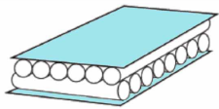
Which technique did you prefer? Why?

