Greek Gods, Goddesses and Heroes
Click on the link below to find out about the Greek Gods and Goddesses:
https://www.bbc.co.uk/bitesize/topics/z87tn39/articles/zgt7mp3
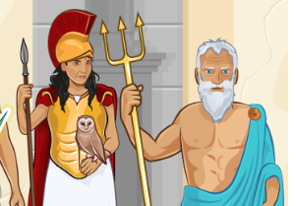
What did you find out? Can you answer these questions?
- How were the Greek Gods and Goddesses different from humans?
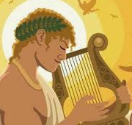
- Where did the Greeks think the Gods lived?

- How did they interfere in what was going on?
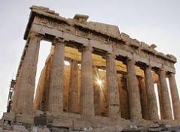
- Where did people go to get help from the Gods?

- What offerings did they give the Gods?

Challenge Task
Design your own God.
Draw a picture of them. Tell me their name.
What do they look like?
Do they have any non-human qualities?
What are their special powers?
What conquests have they had? Who have they fought in battle?
Why are they famous?

