Y3.4 Weekly Maths Activities WB:22.2.21 Multiplication and division
Day | Mental Maths Starter | Activity
Monday | Mental Maths: X Tables Practice  Open and complete the xTables Generator for your year and group (Y3 Product or Multiple, Y4 Product or Multiple)  Practise your x table for 10 minutes at the start of every maths session using the Monster Multiplication and Multiplication 2Dos ready for a test on Friday. | Learning Objective:  I can solve multiplication problems  Review what you have learnt last week about multiplication (grid method, expanded column method).  Then watch Miss McAuley’s video that will follow ppt multiplication 1 and teach you how to use the short column multiplication.  Choose the method you prefer to solve the following calculations.  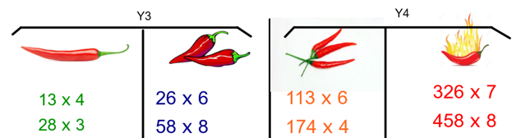  Then solve the following problems:  Year 3 :  - A lorry has 8 wheels. How many wheels would 26 lorries have?  - Hanan is a keen archer. One day he shoots 6 arrows in the 32 point section. How points did he score in total?  - A carpenter makes tables with 3 legs. He is making 67 tables altogether. How many legs does he need to make?  Year 4 :  - A lorry has 8 wheels. How many wheels would 276 lorries have?  - Hanan is a keen archer. One day he shoots 9 arrows in the 352 point section. How points did he score in total?  - A carpenter makes tables with 7 legs. He is making 270 tables altogether. How many legs does he need to make?
Tuesday | X Tables: Monster Multiplication and Multiplication 2Dos  Mental Maths: Counting Forward in Sequences  Y3: Practise counting forward in sequences of 0.5  Y4: Practise counting forward in sequences of 0.25  Record the sequence on a piece of paper. Can you spot any patterns? | Learning Objective: I can solve division using the bus stop method  Watch Miss McAuley’s video that follows ppt Division 1. It will teach you how to use the bus stop method when there are no carrying over.  Then practise solving the following questions:  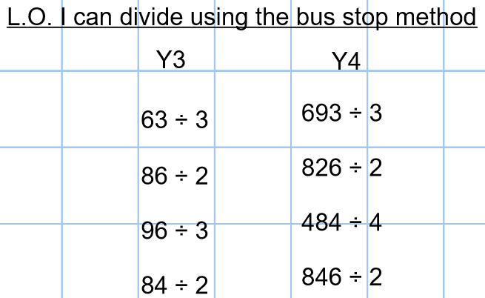  Challenge:  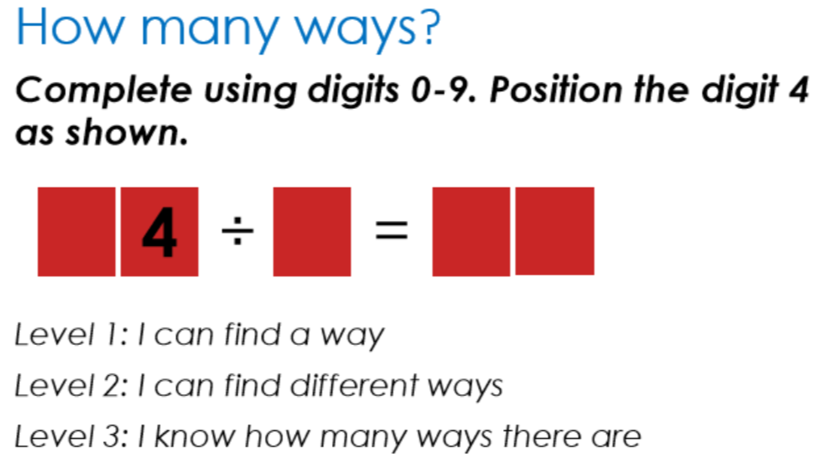
Wednesday | X Tables: Monster Multiplication and Multiplication 2Dos  Mental Maths: Counting Forward and Backward in Sequences  Y3: Practise counting forward and backward in sequences of 0.5  Y4: Practise counting forward and backward in sequences of 0.25  Record the sequences on a piece of paper. Can you spot any patterns? | Learning Objective: I can solve division using the bus stop method  Watch Miss McAuley’s video that follows ppt Division 2. It will teach you how to use the bus stop method with carrying over.  Then complete the following:  Year 3: Year 4: Challenge for all:  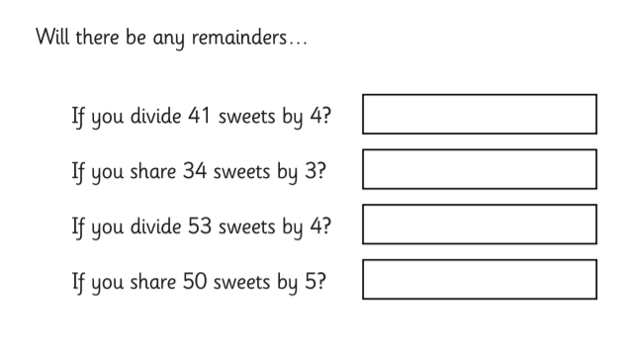  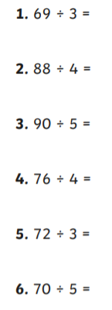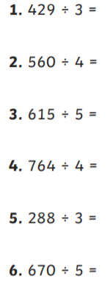
Thursday | X Tables: Monster Multiplication and Multiplication 2Dos  Prepare for your x tables test tomorrow.  Make sure that you can x and divide using the related facts. | Learning Objective: I can solve division problems with remainders (or I can use the bus stop method if you need more practice)  Watch Miss McAuley’s video that follows ppt Division 3. It will teach you how to use solve division questions with remainders and decide whether to round up or down when required.  Then complete the following the worksheet Division 3.  Alternatively, if you are still finding the bus stop method tricky, watch the videos from the previous day again and have a go at the calculations below:  Year 3: Year 4:  42÷2= 642÷2=  96÷3= 396÷3=  48÷3= 189÷9=  68÷4= 288÷6=  75÷5= 336÷8=
Friday | Mental Maths: Times Tables Practice and Test  Complete the x tables questions on the Times Tables Test sheet for your year group.  Self-mark your work out of 45.  Look at any mistakes. Take note of any that you consistently get wrong and learn them. | Learning Objective: To recall my x tables  Play Monster Multiplication OR Multiplication on Purple Mash that have been set as 2Dos.  How efficient and accurate can you be?  Efficiency is about speed and accuracy is about getting your answers correct.  Can you be speedy and accurate?  Additional Task:  Remember the link between fractions and decimals: 0.5=1/2 0.25=1/4.  Can you count in halves (Y3) or quarters (Y4)?  Year 3: counting in halves worksheet.  Year 4: counting in quarters worksheet
 | Additional maths activities | Use measurements:  - • learn to tell the time on an analogue and digital clock  https://www.senteacher.org/printables/freeworksheets/18/Telling-The-Time-Worksheet.html  - • play with jugs and water measuring the capacity of the liquid  - • weigh ingredients – maybe you could do some baking  - • use a ruler or a tape measure to find the length of different objects

